**Comp1168 LabNo6**

Name: Wong, Jui Hsin

CRN: 50138

Student Id: 101559700

Date: 03/10/2025

* Q1

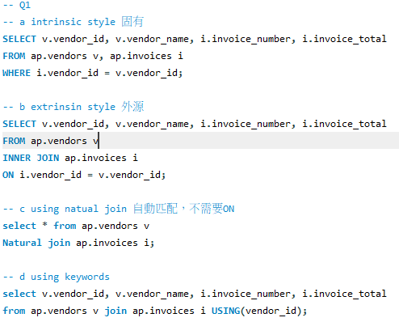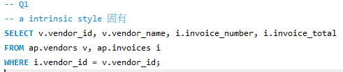

* Q2

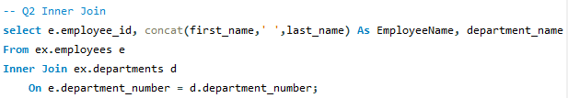

* Q3

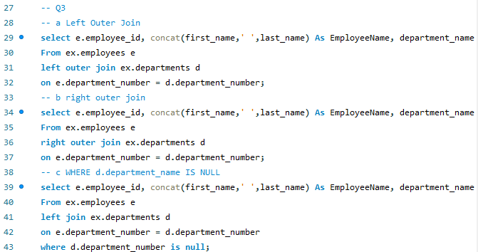

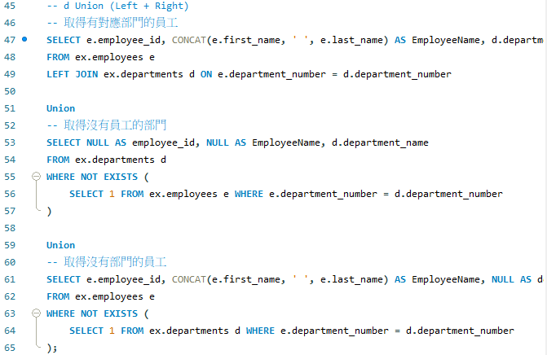

* Q4

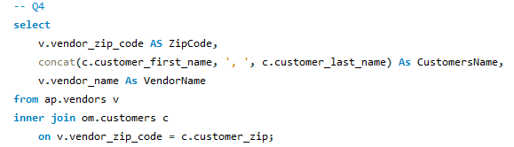

* Q5

